Coursera data science math skills

Sigma notifications

1.intro

The top value is **the end value**

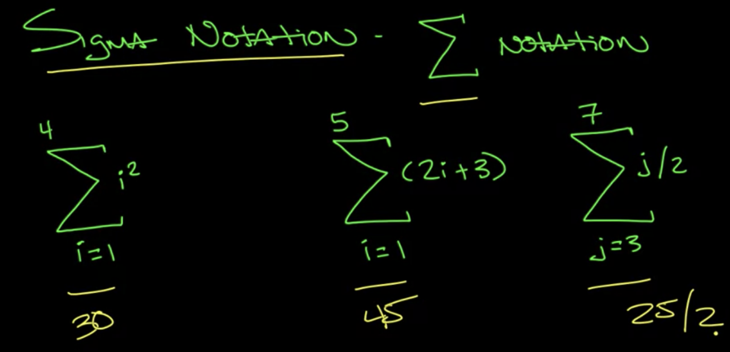

1+4+9+16 = 30

5+7+9+11+13 = 45

(3+4+5+6+7)/2 = 25/2

2.simplification rules

Pull the constant in the multiplication out of the value

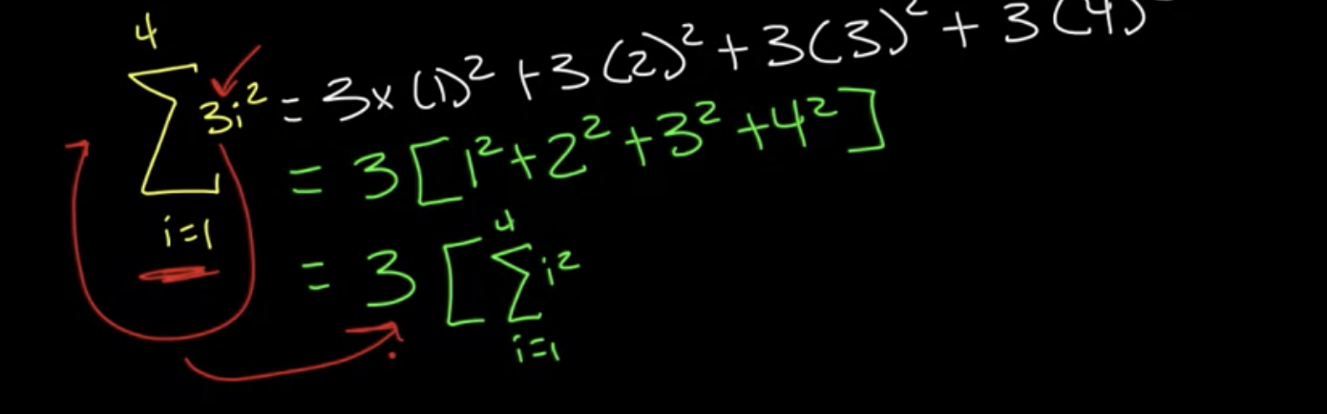

Separate the additions with plus

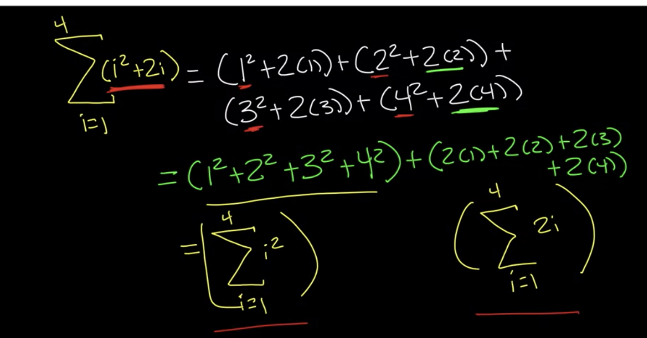

Deviation and standard deviation

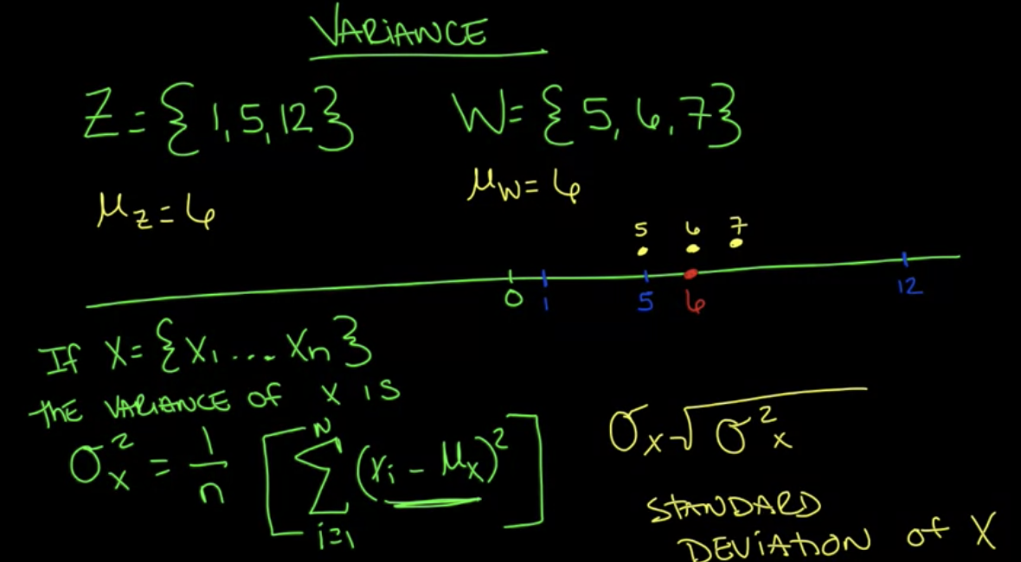

Composition symbol for functions: watch the order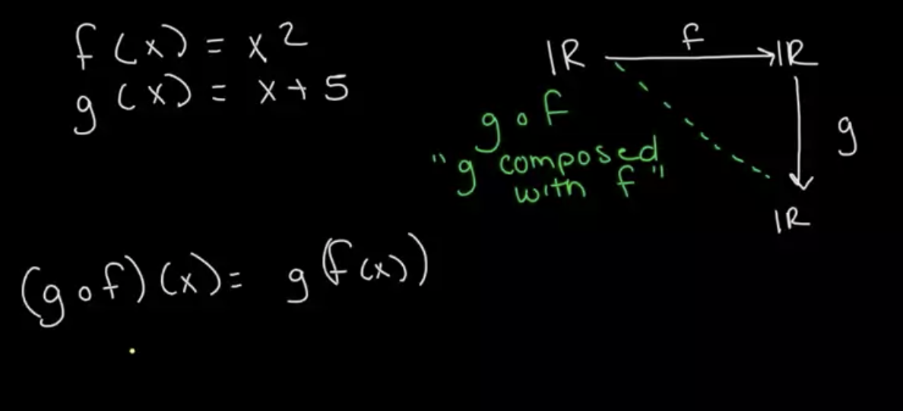

Logrithm

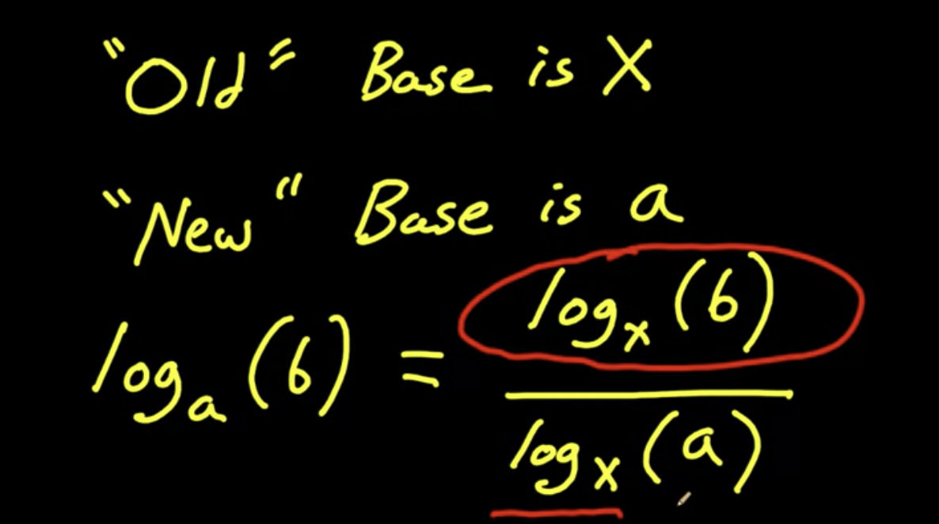

**Use LN for continuous increase/decay computations**

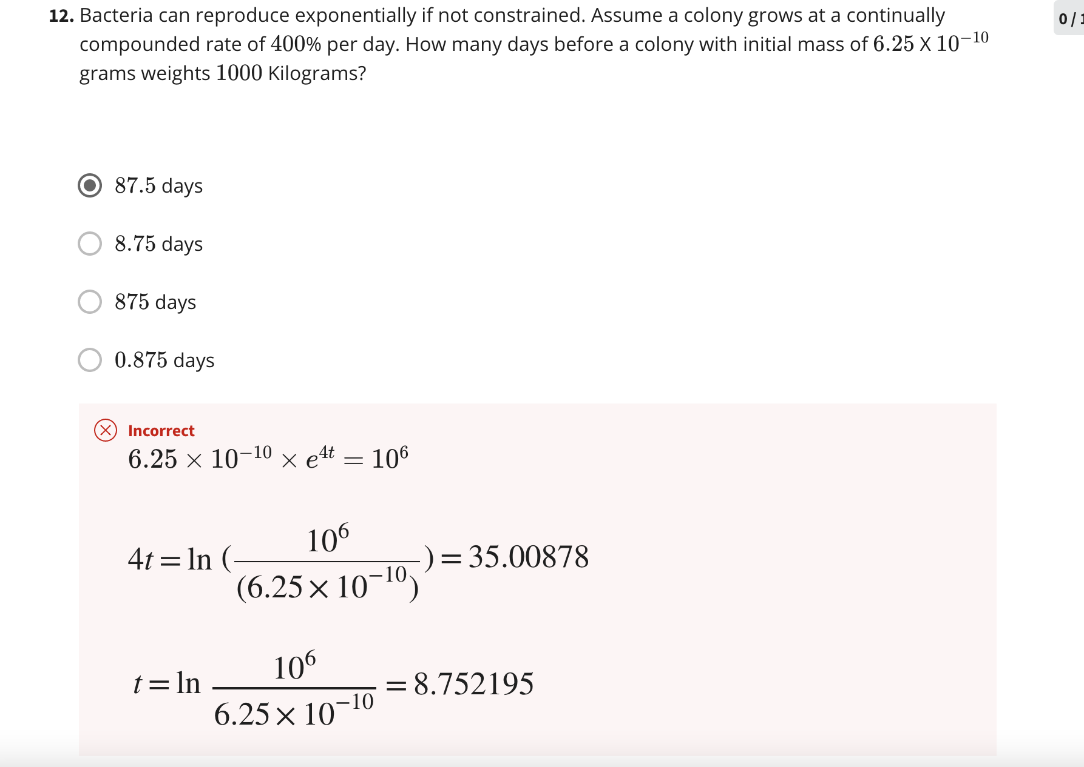

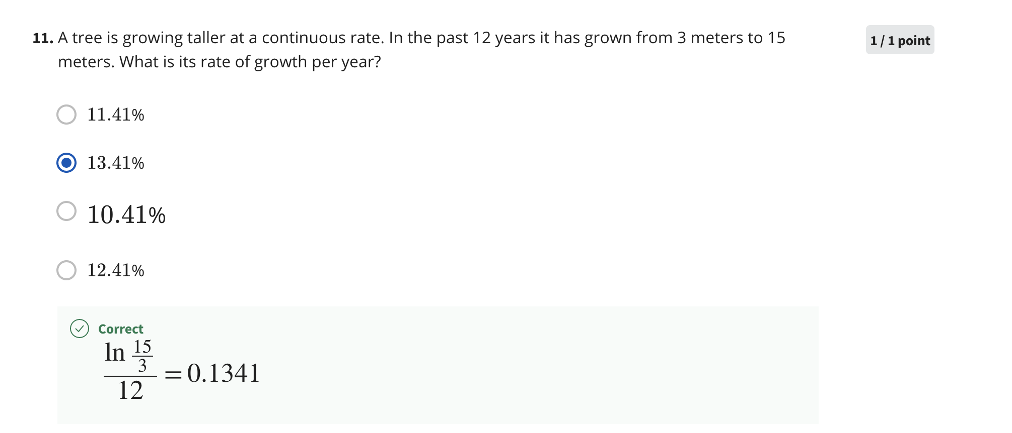

OR probability

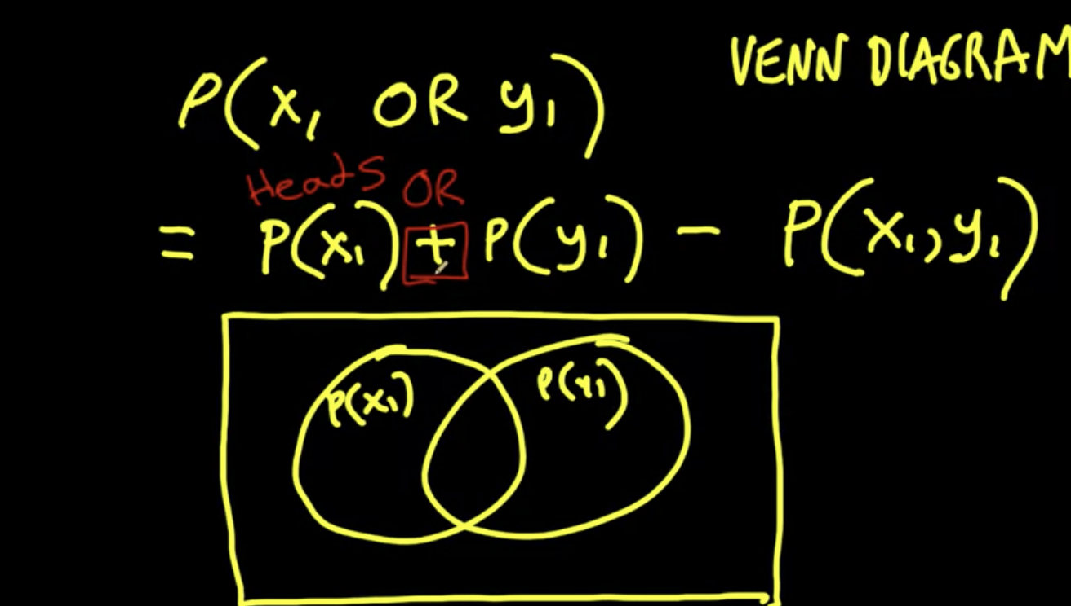

Permutation (there is an ordering): A (x,y)

n!/(n-m)!

Combination (ordering doesn't matter): C(x,y) → N choose M

n!/(n-m)!*m!

Joint probability (for X1 or Y1) means the sum of columns of rows

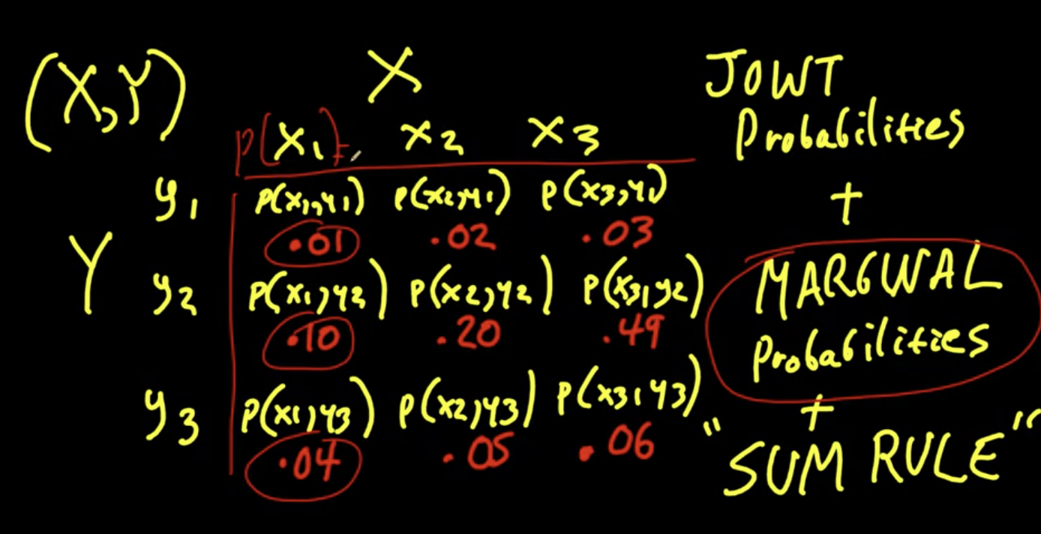

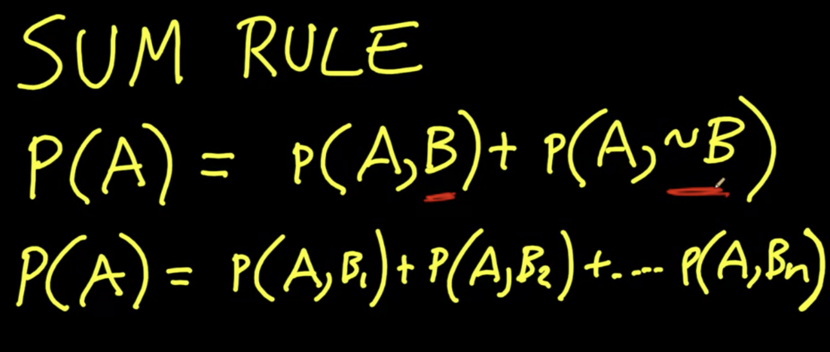

Conditional probability

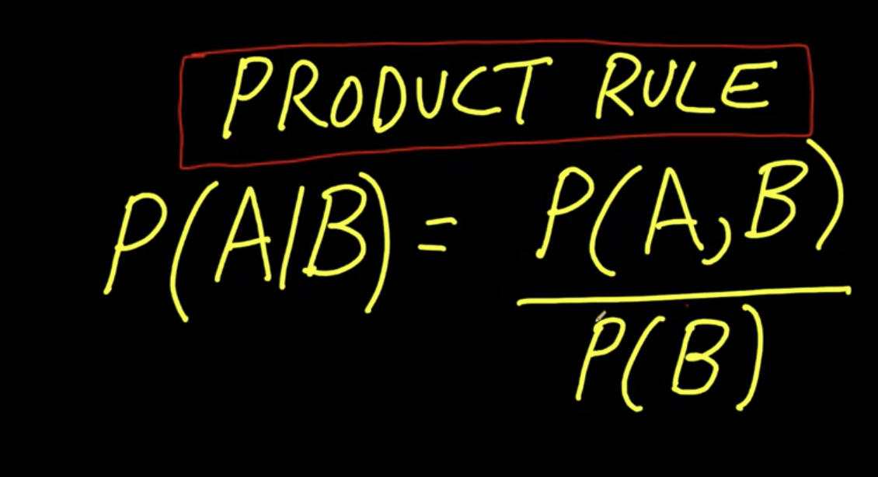

Bayes

**P(A|B) = P(B|A) * P(A) / P(B)**

**B: observable data**

**A: possible process i with parameters “thera subi”**

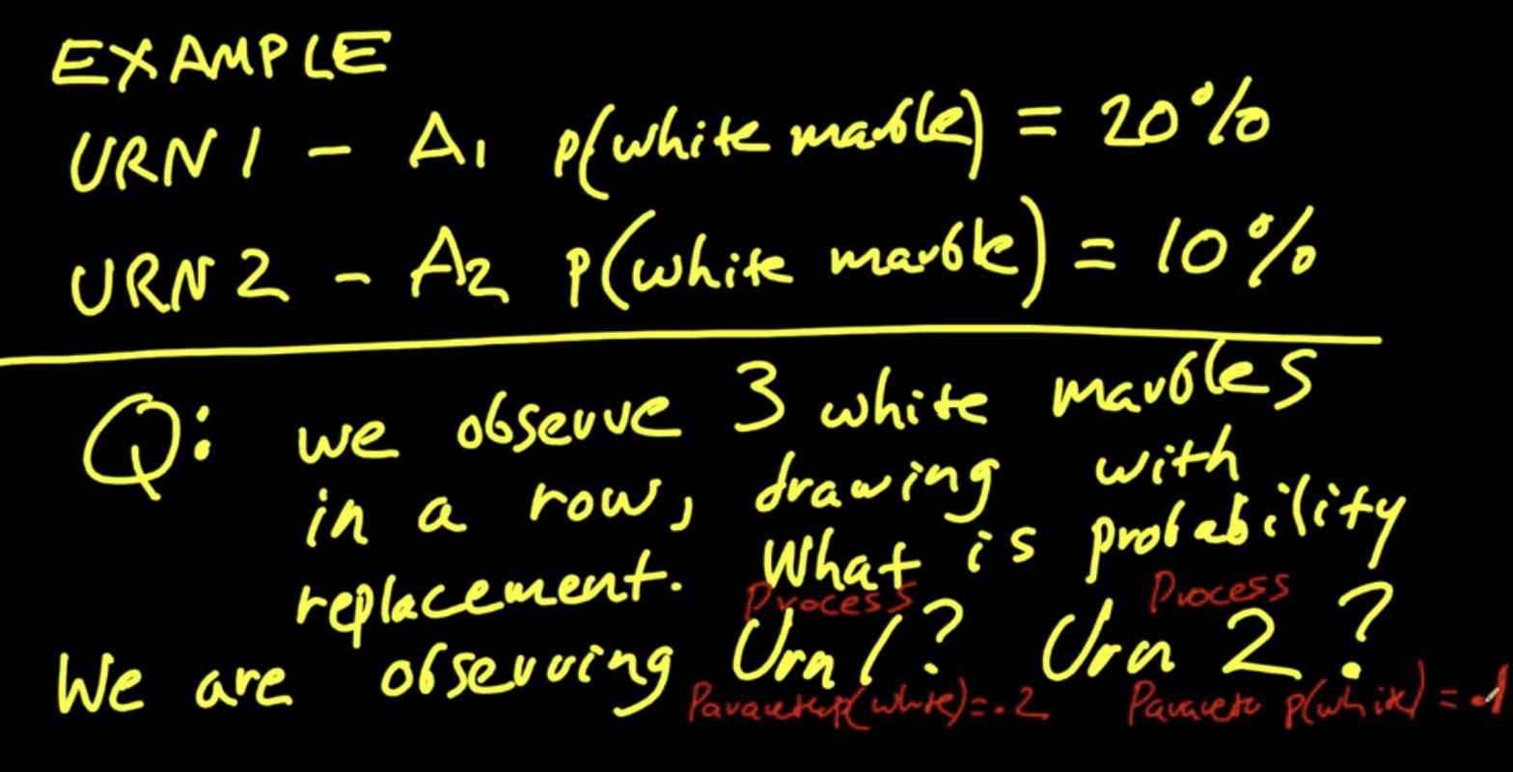

**P (process parameter | observed data)**

**= P (observed data | process parameter i) * P(process i)**

**/ P(B)**

**Here P(B) = [P(observed data | parameter1)P(process parameter1)**

**+ P(observed data | parameter2)P(process parameter2) + … + P(observed data | parameterN)P(process parameterN)]**

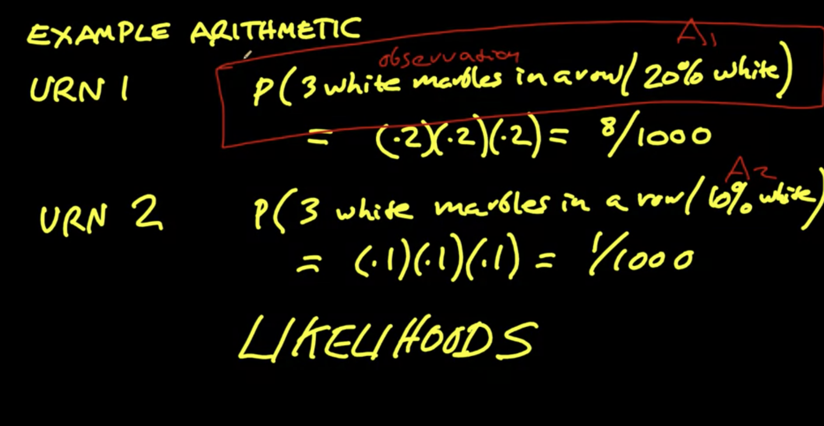

**Solution**

**Principle of indifference**

**Assuming, P(A1) = P(A2) = 0.5 (they are called prior probability)**

**Plugin in P(A)**

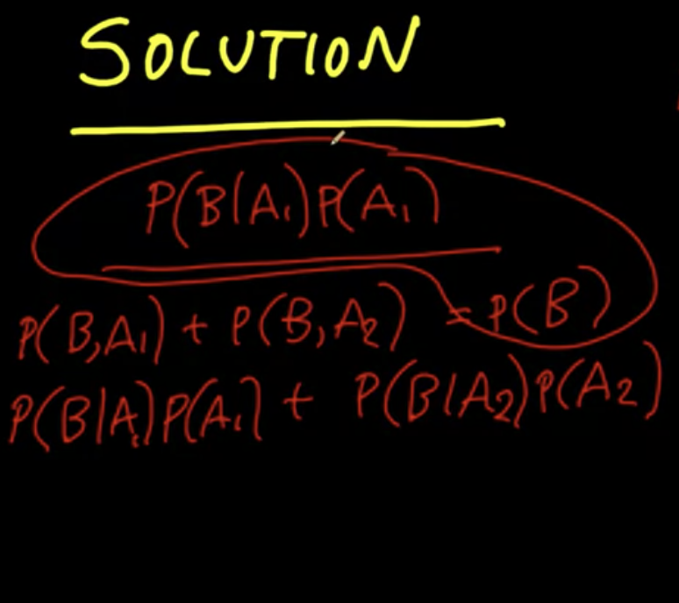

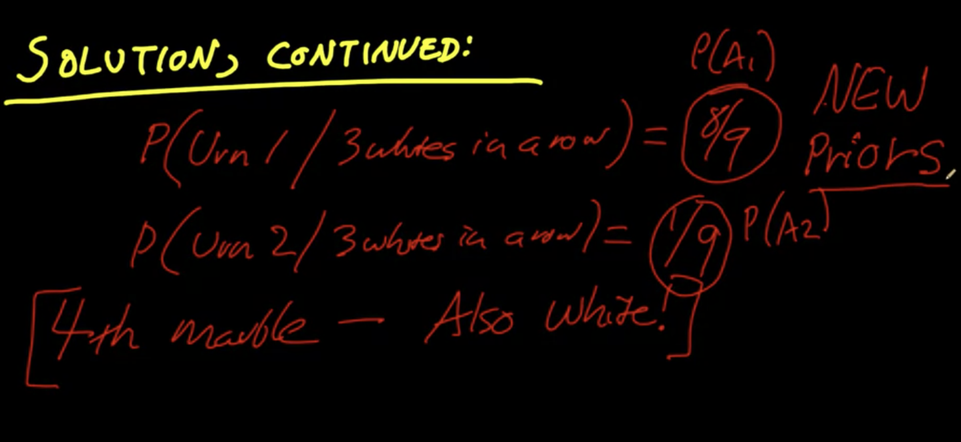

**Suppose we have a fourth white marble:**

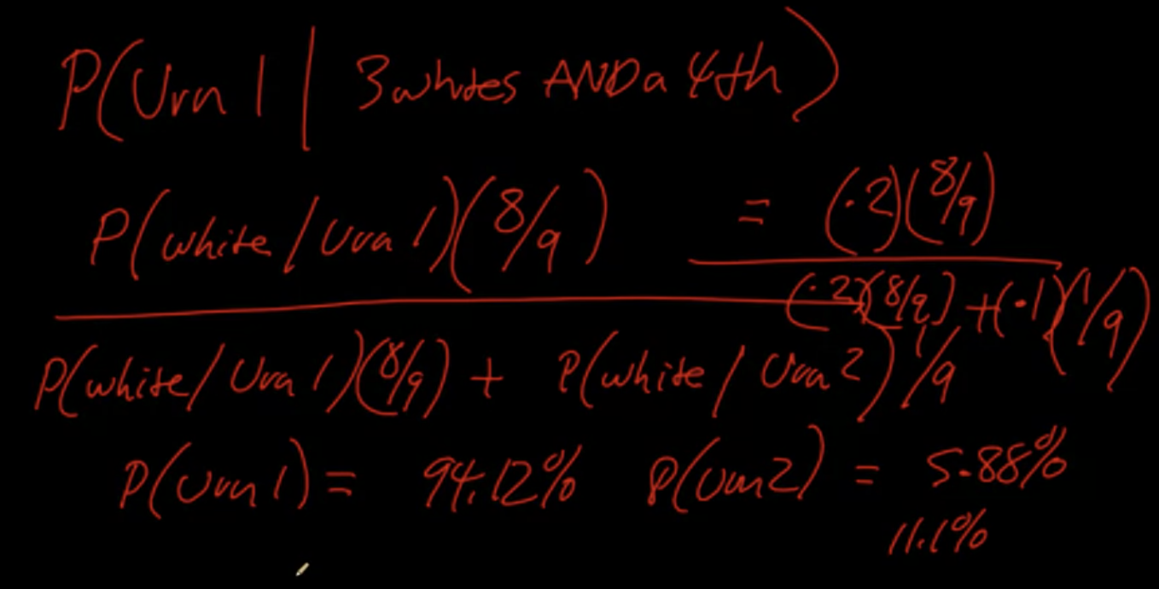

**Technical expressions:**

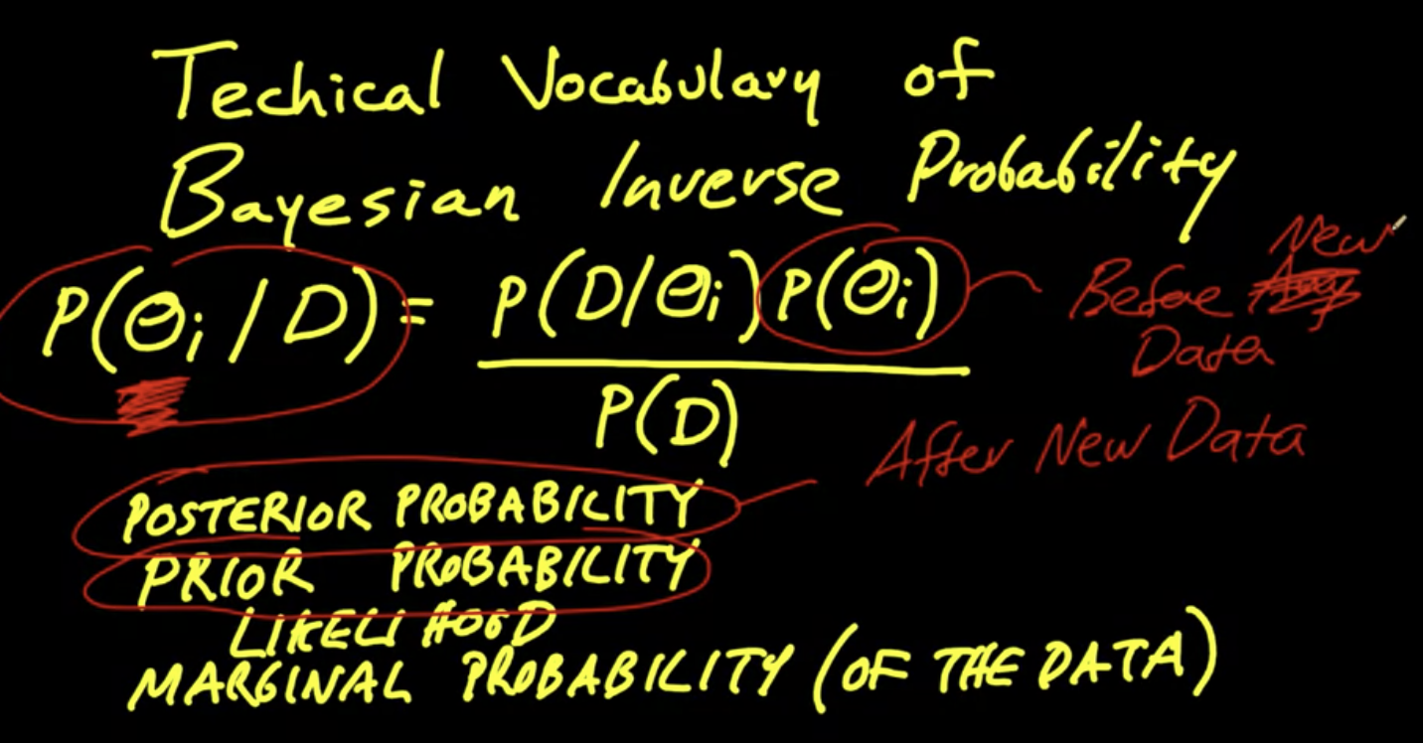

The binomial theorem and bayesian

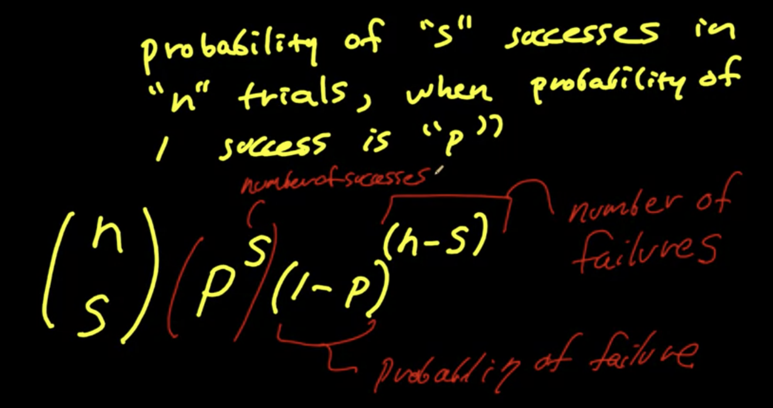

Example:

(1)

72 heads out of 100 coin tosses; fair coin;

N = 100, s = 72, p =0.5

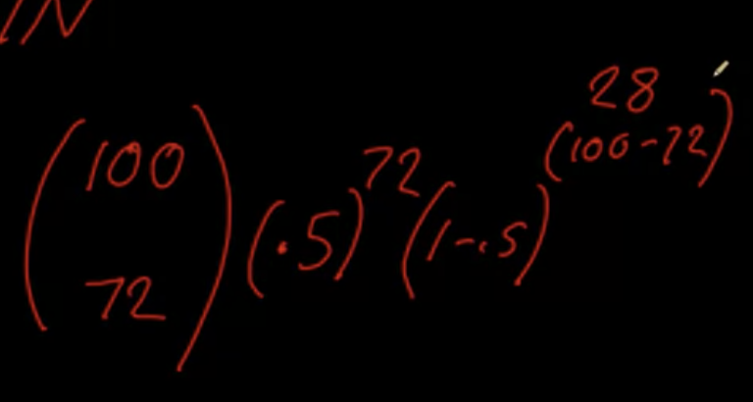

3.94 * 10^(-6)

(2) there are two coins

Fair coin has p=0.5 heads

Bent coin has p=0.55 heads

What is the probability we observed in the fair & bent coins?

